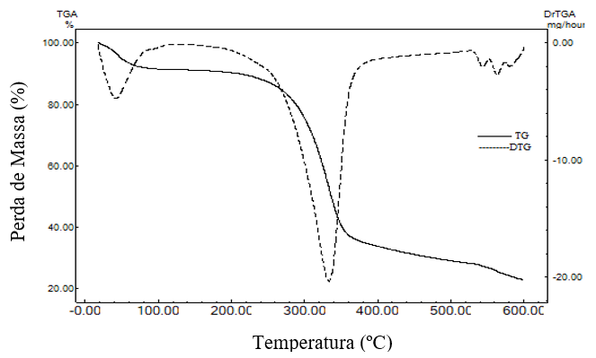
Pic.4 – presents the TA/DTA from stem from MoLAM
LOSS OF PLANT MASS (%)/TEMPERATURE (º C)
The Figure 4 introduces TA/DTA curves from the stem and from these curves it was possible to determine the second stage, which starts at 390,2 º F and ends at 634,478 º F accounting 36.56% mass loss from the sample also associated to cellulose decomposition, which are constituents from the sample and lastly the third stage starts at 659,714 º F and ends at 1.112 º F, where occurs maximum mass degradation from the stem accounting for 30.16% from the total sample mass, being associated to the lignin and hemicellulose decomposition.

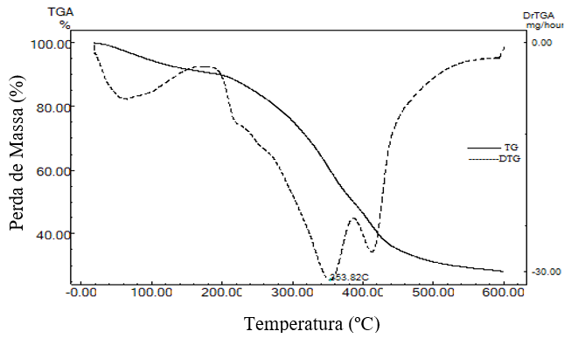
Pic.5 – TA and DTA curves from MoLAM pie
LOSS OF PLANT MASS (%)/TEMPERATURE (º C)
For the pie (Picture 5), the second stage begins at 389,318 º F and ends at 658,634 º F, representing 29.90% mass loss from the sample, and may be associated with the extractives and cellulose decomposition, which are constituents from the sample. The third stage starts at 658,4 º F and ends at 1.112 º F, which is the range where the maximum mass degradation occurs, accounting for 61.61% from the total mass, attributed mainly to the oil from the pie degradation, the hemicellulose and lignin decomposition.
Proteins, carbohydrates, hemicellulose, cellulose and lignin degradation is characterized by the elimination of the absorbed water on the crushed biomasses, from the volatile organic matter decomposition (ARAUJO et.al,2010).
The materials used in CL control should be able to respond positively to problems concerning the stability of their additives when subjected to high temperatures. There is a portion of drilled wells characterized as HPHT (High Pressure High Temperature) where internal temperatures are considered high, for example, the Brazilian pre-salt layer wells. In this way, it is necessary to develop new materials with resistance to temperature that are able to fight CL. In this way, LCMs must have physical and chemical characteristics that are suitable for such applicability. By this, MoLAM becomes a possible material that be used in to fight the loss of circulation since its degradation occurs at temperatures close to 68 º F and with maximum mass degradation near 752 º F, obtaining an equal or lesser mass loss when compared to commercial ones.

Chart 1 – MoLA-derived LCMs temperature range with commercials ones
Sample | Temp. range  1st stage | Total of mass loss | Temp. range  2nd stage | Total of mass loss | Temp. range  3rd stage | Total of mass loss |  | Author
String bean | 30-100ºC | 9.0 % | 198-348ºC | 34.21% | 348-600ºC | 26,3% |  | This academic study
Stem | 30-100ºC | 7.11% | 198-348ºC | 36.56% | 348-600ºC | 30.16% |  | This academic study
Pie | 30-100ºC | 5.4% | 198-348ºC | 29.98% | 348-600ºC | 61.6% |  | This academic study
Seam fiber | 64.7ºC | 10.52% | 282.3 ºC | 9.38% | 345.2ºC | 65.3% |  | Das et al. (2000)
Coconut fiber | 50-100ºC | 5.4% | 265-282 ºC | 19.6% | 327 ºC | 40.1% |  | Leão et al. (2015)  Tomczak et al. (2007)
Nut shell | 30-184ºC | 5% | 184-310ºC | 11% | 310-383ºC | 39,0% | Medrano et al. (2016)
Pine sawdust | 30-150ºC | - | 200-500ºC | 74.48% | > 500°C | - |  | (Mishra and Mohanty, 2018)
Source: Elaborated by the author himself
Differential Scanning Calorimetry (DSC)
From Picture 6 is observed that, for the pie, at the temperature 121,28 º F, a first melting spike is observed and can be attributed to the release of the absorbed water which is attached to the material. Subsequently an exothermic event is observed at 782,744 º F, which may be attributed to the oil residues that have been vaporized or a possible polymeric oxidation. From the samples made from the bean string it is possible to observe a peak at 121,28 º F which can be attributed to vaporization of the still present in the interstitial water from the fiber and a second discrete endothermic event occurring at 794,624 º F. This decomposition or dissociation spike can be attributed to lignin polymer fractions present in the sample. In the stem samples a number of melting events are observed on, which can be attributed to the various components from the biomass composition, although the spike happens at 208,454 º F, is the melting point and a second endothermic event occurs at 752 º F assigned from the hemicellulose decomposition present in the material. Lastly, from the sponge samples, fusion events is observed on, which can be attributed to the various components from the biomass, with a melting spike occurring at 122 º F, which can be attributed to the release from the adsorbed water that is trapped in the material and subsequently a second discrete exothermic event occurring at 788 º F which may be related to the decomposition from the hemicellulose and lignin polymeric fractions in the material.

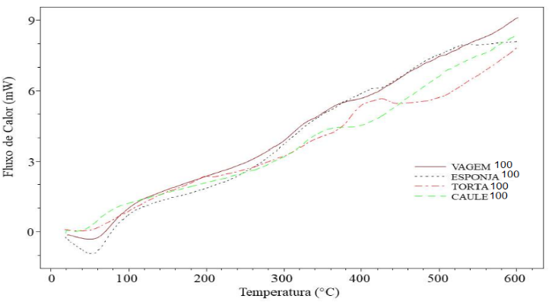
Pic.6 – The DSC curves from the pie, bean string, stem and bean string sponge derived from MoLAM
FLUXO DE CALOR(mW)/TEMPERATURE (º C)

Differential Scanning Calorimetry (DSC) is a thermochemical technique to determine the biomass heat flow property. The DSC analysis measures the biomass property by weight difference from the reference holder and the sample holder. Thus, DSC thermochemical techniques measure the biomass heat flow in relation to temperature and time. By correlating the in natura samples from the materials derived from MoLAM with the literature materials (Chart 2), it is possible to verify that the results from the DSC analysis are obtained through two events, the first event establishes that the curve went through the endothermic region and the second event in the exothermic region. We can also conclude that the first event occurred in the temperature range from 86 through 302 º F, due to the evaporation of adsorbed water molecules, which means the occurrence of endothermic processes. In the temperature range of 302 to 1.112 º F, the observed event was due to the cellulose, hemicellulose and lignin degradation compounds present in the sample. From the analysis it is possible to verify that the compounds degradation for the LCMs derived from MoLAM are in the higher temperature range than the commercial ones, showing the efficiency to be used in HPHT wells. The results obtained from the DSC analysis corroborate with thermal events observed during TA tests that were conducted through the same temperature range.

Chart 2 – Comparison from DSC from LCMs derived from MoLAM with commercial ones.
Material | First event Tp (ºC) | Second event  Tp (ºC) | Author
String Bean | 49.60 | 423.68 | This academic study
Pie | 49.60 | 417.08 | This academic study
Stem | 98.03 | 400.0 | This academic study
String bean sponge | 50 | 420 | This academic study
Rice shell | 150 | 320 | Rosa et al. (2012)
Nut shell | 56 | 236 | Medrano et al. (2016)
Pine sawdust | 100 | 150 a 500 | Mishra and Mohanty (2018)
Source: Elaborated by the author himself

Scanning Electron Microscopy (SEM)
The morphology from the “ in natura” materials from MoLAM as well as the Fracseal materials commercial ones were investigated by scanning electron microscopy (SEM). Images were obtained by using 30,250 and 1.000 times magnification. The micrographs of each material indicated the presence of asymmetric pores and structure of open pores and their surface area.
- Bean string
It can be observed through Picture 7 that the LCM derived from the bean string presents morphological characteristics quite heterogeneous, with changes in the morphology on materials in terms of size and pore formation, as well as an irregular structure, presenting dense characteristics. The bean string is shown with less agglomerated pores and with planar structure. Picture 7a and 7b shows the presence of surface deformation, ie, the geometry from LCM and its flat structure. It is further observed by that the particles agglomerating themselves containing small spaces between the particles, and an irregular and heterogeneous structure, which enables favorable conditions to be used in the fluid to fight the circulation loss. Picture 7c in 1000 x magnification clearly shows the shape and size distribution of the pores, with a heterogeneous matrix and, relatively, with few pores, it can be seen that not all particles have internal pores, and when enlarged, they show that these particles can form folds and because they have flat structures and with few pores, causes these fibers to form much smaller agglomerations preventing the passage of the fluid and that there is no rupture on the fibers. Such structure facilitates the adsorption process, allowing the conclusion that the material has suitable morphological profile for fluid retention and formation of a plaster on the well’s wall.
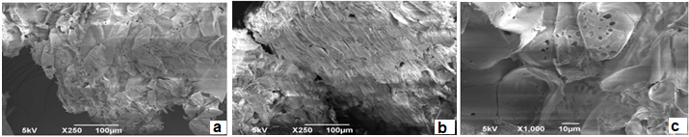
Pic. 7 – Micrograph obtained by SEM for the “in natura” bean string (a) and (b) 250X magnification, (c) 1000X magnification.

- Stem
In Picture 8a and 8b it can be observed that the material presents morphological characteristics
distributed with heterogeneity and, relatively, with few pores. The presence of deformation on the plant tissue surface is visible, with available spaces that allow favorable conditions for adsorption.

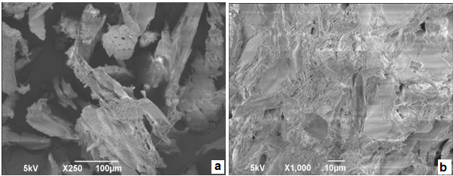
Pic. 8 – Micrograph obtained by SEM for the “in natura” stem (a) and (b) 250X magnification, (c) 1000X magnification.

Picture 8 shows deformation on the surface, that is, the LCM geometry structure, which shows how the particles clustered containing spaces between them. Picture 8b at 1000x magnification clearly shows the surface from the “ in natura” stem with the few pores. It can be verified that the fiber surface is very rough and presents few pores, admitting that material has a suitable morphological profile for retention of drilling fluid in fight of circulation loss.

- Pie
After analyzing the results obtained by scanning electron microscopy from MoLAM derived pie, although it did not undergo any chemical modification, it can be seen from Picture 9a and 9b that the material presents a matrix with a heterogeneous distribution with relatively few pores. This feature is justified by the fact that the seed is whole-wheat and has diversity of components that make up the fiber in study, such as cellulose, hemicellulose and lignin.

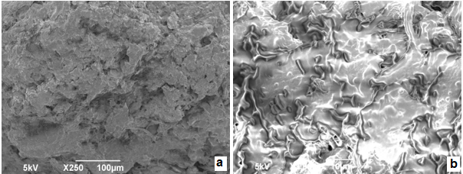
Pic.9 - Micrograph obtained by SEM for the “in natura” pie (a) and (b) 250X magnification, (c) 1000X magnification.

It is visible in Picture 9a how some deformation can be seen on the surface, as well as particles deformation, when the sample was pressed, causing mechanical, the fibers became more rounded, giving an appearance of several stria, differing from other materials that have an irregular structure. These particles cannot gather themselves and close all the spaces between them. Picture 9b, in magnification, shows that these particles have structures with practically no internal pore, causing these fibers to form much smaller agglomerations preventing the passage of the fluid.

- Sponge
Pictures 10 a-c are micrographs obtained by SEM from the “ in natura” bean string sponge under various magnifications. Picture 10a clearly shows the particle shapes and the pores distribution from the bean string sponge.
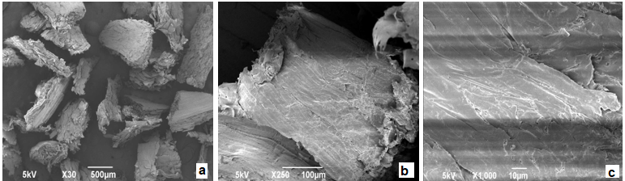
Pic.10 - Micrograph obtained by SEM for the “in natura” sponge (a) and (b) 250X magnification, (c) 1000X magnification.

It is observed by in Picture 10a at 30x magnifications that some macro fibrils remain separated, while other agglomerate. In addition to the irregular shape of the particles is also observed by, which facilitates the closure of the spaces left behind after a certain pressure. Picture 10b shows the morphology, called microfibers bundles at the point of each particle, containing available spaces that favorable conditions for fluid adsorption.
The analyzed micrographs by 1000 x magnification demonstrated in Picture 10c allowed to visualize the surface of the bean string sponge, which allows to verify that this material has a flat, smooth and without pores surface. The amount of pores present in this material are very similar in size and are at the ends of the particles, and these characteristics contribute to increase the surface resistance and consequently to retain more fluid, containing available spaces, the characteristics of which allows to infer that the adsorbent of fluids in the interstices.

- Fracseal
The analyzed micrographs with different magnifications allowed to visualize the characteristics from the commercial material Fracseal presenting very homogeneous morphological characteristics, where it was confirmed by Picture 11a and 11b shows that the particles agglomerate themselves with small spaces between them, and an irregular and heterogeneous structure that allows favorable conditions to be used in a fluid in fight of circulation loss. In Picture 11c it was possible to visualize the Fracseal LCM and this material has a flat and smooth surface with no pores, as the pores in this material have many small sizes , and these contribute to increase the surface resistance and, consequently, to retain greater amount of fluids, assuming that the material has a morphological profile suitable for retention of drilling fluid in fight of circulation loss.
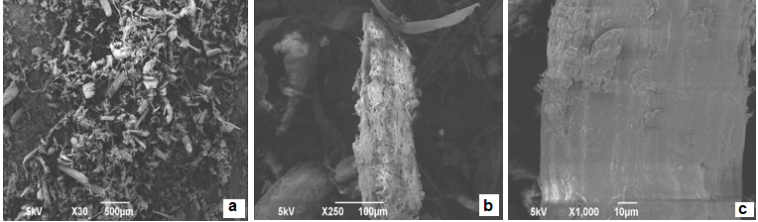
Pic.11 - Micrograph obtained by SEM for the Fracseal (a) and (b) 250X magnification, (c) 1000X magnification.

When comparing the LCMs derived from MoLAM with the commercial LCM, it is observed that these have very heterogeneous morphological characteristics, with changes in the morphology of the materials in terms of particle geometry, size and pore formation. From the MoLAM LCMs, as well as the Fracseal’s, the presence of deformation on the surface is visible, and they have relatively few porous and irregular geometries. Such structure justifies the fluid retention process, allowing to confirm that the materials derived from MoLAM have a morphological profile suitable for fluid retention in fighting the circulation loss in oil wells.

X-Ray Diffractions (XRD)
The data from Pictures 12 to 15 derived from MoLAM and Fracseal (picture 16) show the behavior from the “in natura” fibers, where the graph of intensity in relation to 2Ɵ is given. XRD analysis was performed to determine whether the chemical modification from the fibers has altered the fibers crystallinity. Since the fibers presented a similar behavior and amorphous and semicrystaline characteristics materials, with intense spikes.
…
Conclusion
The study demonstrates the potential of using fibrous materials derived from Moringa Oleifera Lam, in the fight against the circulation losses in drilling oil wells with rocky and permeable formations.
All the investigated materials derived from MoLAM presented maximum mass degradation between 572 º F and 1.112 º F. Among the evaluated materials, the pie showed better thermal stability results. Through DSC analysis, it can be concluded by that the compounds degradation from the MoLAM derived LCMs are in the higher temperatures range than the commercial ones, showing the efficiency to be used in HPHT wells. The obtained results from the DSC analysis corroborated with thermal events observed by during TA tests that were conducted in the same dynamic conditions.
In the SEMs analysis, all the materials investigated had the potential to be used in fluids to fight circulation loss, as it presents few pores in the particles and physical properties that helps the coupling of two or more particles into the formation of plaster on the wall of the well. The pie and sponge materials from the moringa were the ones that presented better results having practically no internal pore structures, causing these fibers to form much smaller agglomerations, which are characteristics that make it possible to infer that the adsorbent has favorable conditions for the retention of fluids into the formed plaster.
The results from the XRD showed the existence of “unresolved” spikes indicating the dominance of the amorphous material, which is ideal for the LCMs, especially the moringa pie. The Fracseal commercial one showed similar behavior to the moringa derived LCMs, it is possible to observe a broad spike in all the moringa derivate and also in the Fracseal one around 2Ɵ of 77 º F, which corresponds to the presence of crystalline structures.
Relating mass loss with porosity, it was observed that the LCMs derived from MoLAM showed good outturning with reduced mass loss, showing that at high temperatures ( 658,4 – 1.112 º F ) the maximum mass degradation was maintained in almost 62% from the total mass, being that for the bean string was 26,30%, stem 30.16% and lastly the pie 61.61%. Giving emphasis to the higher outturning on the bean string for its total loss close to 26% of it mass, which may be associated with the resistance of cellulose, hemicellulose and lignin decomposition in the material, making it an alternative to be used in HPHT wells.
Through the thermal analysis, it is possible to be said that the LCMs present a great potential to be used to fight fluids of CL in HPHT oil wells, since they denote good characteristics for this purpose, being that the particle size distribution, the physical and thermal stability should be investigated prior to the use of LCM in drilling fluids in fight of circulation loss.

Acknowledgments
The authors would like to acknowledge the Universidade Federal of Sergipe – UFS and the Laboratorio of Energia Alternativas – LTA/UFS.

References
ALMAGRO, S. P. B.; FRATES, C.; GARAND, J.; MEYER, A. Sealing Fractures: Advances in Lost Circulation Control Treatments. Oilfield Review, v. 26, n. 3, p. 4-13, 2014.

ARAÚJO, C. S.; ALVES, V. N.; REZENDE, H. C.; ALMEIDA, I. L.; DE ASSUNÇÃO, R. M.; TARLEY, C. R.; SEGATELLI, M. G.; COELHO, N. M. M. Characterization and use of Moringa oleifera seeds as biosorbent for removing metal ions from aqueous effluents. Water Science and Technology, v. 62, n. 9, p. 2198-2203, 2010. ISSN 0273-1223.

BHUPTAWAT, H.; FOLKARD, G.; CHAUDHARI, S. Innovative physico-chemical treatment of wastewater incorporating Moringa oleifera seed coagulant. Journal of Hazardous Materials, v. 142, n. 1, p. 477-482, 2007. ISSN 0304-3894.

CUINICA, L. G.; MACÊDO, R. O. Thermoanalytical characterization of plant drug and extract of Urtica dioica L. and kinetic parameters analysis. Journal of Thermal Analysis and Calorimetry, v. 133, n. 1, p. 591-602, 2018. ISSN 1388-6150.

DAS, S.; SAHA, A.; CHOUDHURY, P.; BASAK, R.; MITRA, B.; TODD, T.; LANG, S.; ROWELL, R. Effect of steam pretreatment of jute fiber on dimensional stability of jute composite. Journal of applied polymer science, v. 76, n. 11, p. 1652-1661, 2000. ISSN 1097-4628.

DE ANDRADE, L.; FRANÇA, F.; RAMOS, A.; DA SILVA, G. INFLUÊNCIA DA ATIVIDADE ANTIOXIDANTE EM DIFERENTES PERCENTUAIS DE DIESEL/BIODIESEL UTILIZANDO O COMPOSTO ADITIVO OBTIDO A PARTIR DA MORINGA OLEIFERA LAM. Blucher Chemical Engineering Proceedings, v. 1, n. 2, p. 850-856, 2015. ISSN 2359-1757.

DE ANDRADE, L. C. T.; FRANÇA, F. R. M.; RAMOS, A. L. D.; DA SILVA, G. F. Avaliação da estabilidade do biodiesel produzido a partir da moringa oleifera lam. Scientia Plena, v. 12, n. 5, 2016. ISSN 1808-2793.

DEDAVID, B. A.; GOMES, C. I.; MACHADO, G. Microscopia eletrônica de varredura: aplicações e preparação de amostras: materiais poliméricos, metálicos e semicondutores. EdiPUCRS, 2007. ISBN 8574307025.

FERREIRA, P. M. P.; FARIAS, D. F.; OLIVEIRA, J. T. D. A.; CARVALHO, A. D. F. U. Moringa oleifera: bioactive compounds and nutritional potential. Revista de Nutrição, v. 21, n. 4, p. 431-437, 2008. ISSN 1415-5273.

FUGLIE, L. J.; FUGLIE, J. The miracle tree: The multiple attributes of Moringa. 2001

ISHIZAKI, M. H.; VISCONTE, L. L.; FURTADO, C. R.; LEITE, M. C.; LEBLANC, J. L. Caracterização mecânica e morfológica de compósitos de polipropileno e fibras de coco verde: influência do teor de fibra e das condições de mistura. Polímeros: Ciência e Tecnologia, v. 16, n. 3, 2006. ISSN 0104-1428.

KULKARNI, S. D.; JAMISON, D. E.; TEKE, K. D.; SAVARI, S. Managing Suspension Characteristics of Lost-Circulation Materials in a Drilling Fluid. SPE Drilling & Completion, v. 30, n. 04, p. 310-315, 2016. ISSN 1064-6671.

LEÃO, R.; LUZ, S.; ARAUJO, J.; NOVACK, K. Surface treatment of coconut fiber and its application in composite materials for reinforcement of polypropylene. Journal of natural fibers, v. 12, n. 6, p. 574-586, 2015. ISSN 1544-0478.

LUCENA, D. Avaliação de ligantes asfálticos modificados com óleo da Moringa Oleífera Lam para uso em misturas mornas. Revista Matéria, v. 21, n. 1, p. 72-82, 2015. ISSN 1517-7076.

______. Avaliação de ligantes asfálticos modificados com óleo da Moringa Oleífera Lam para uso em misturas mornas. Revista Matéria, v. 21, n. 1, p. 72-82, 2016. ISSN 1517-7076.

LUZARDO, J.; OLIVEIRA, E.; DERKS, P.; NASCIMENTO, R. V.; GRAMATGES, A. P.; VALLE, R.; PANTANO, I. G.; SBAGLIA, F.; INDERBERG, K. Alternative Lost Circulation Material for Depleted Reservoirs. OTC Brasil, 2015, Offshore Technology Conference.

MAKKAR, H.; BECKER, K. Nutrients and antiquality factors in different morphological parts of the Moringa oleifera tree. The Journal of Agricultural Science, v. 128, n. 3, p. 311-322, 1997. ISSN 1469-5146.

MEDRANO, J. A. L.; MARTÍNEZ, D. B.; DE LA ROSA, J. R.; PEDRAZA, E. S. C.; FLORES-ESCAMILLA, G. A.; CIUTA, S. Particle pyrolysis modeling and thermal characterization of pecan nutshell. Journal of Thermal Analysis and Calorimetry, v. 126, n. 2, p. 969-979, 2016. ISSN 1388-6150.

MIRANDA, C.; OLIVEIRA, J.; CAVALCANTE, G.; D'ALMEIDA, A.; PEREIRA, R.; SANTOS, R.; SURMAS, R. Materials for Controlling Severe Lost Circulation-Laboratory Evaluation. SPE Latin America and Caribbean Petroleum Engineering Conference, 2017, Society of Petroleum Engineers.

MISHRA, R. K.; MOHANTY, K. Pyrolysis kinetics and thermal behavior of waste sawdust biomass using thermogravimetric analysis. Bioresource Technology, v. 251, p. 63-74, 2018/03/01/ 2018. ISSN 0960-8524. Disponível em: < http://www.sciencedirect.com/science/article/pii/S0960852417321624 >.

NELSON, E. B., GUILLOT, D. Well Cementing. Schlumberger, v. second edition, 2006.

NUNES, E. N.; ROCHA, A. P. T.; DE ARAÚJO, G. T.; DE PAZ, A. P.; DE SOUSA RODRIGUES, L. M.; DE ARAÚJO BATISTA, R. S.; MELO, T. B. L. Characterization of yellow mombin biomass (Spondias mombin L.) for production of activated carbon. Journal of Thermal Analysis and Calorimetry, p. 1-8, ISSN 1388-6150.

______. Characterization of yellow mombin biomass (Spondias mombin L.) for production of activated carbon. Journal of Thermal Analysis and Calorimetry, p. 1-8, 2018. ISSN 1388-6150.

OYEYINKA, A. T.; OYEYINKA, S. A. Moringa oleifera as a food fortificant: recent trends and prospects. Journal of the Saudi Society of Agricultural Sciences, 2016. ISSN 1658-077X.

PEREIRA, F. S. G.; DA SILVA, A. M. R. B.; GALVÃO, C. C.; DE LIMA, V. F.; DE ASSUNÇÃO MONTENEGRO, L. G. L.; DE LIMA-FILHO, N. M.; DA SILVA, V. L. Moringa oleifera as sustainable source for energetic biomass. International Journal of Chemistry, v. 7, n. 2, p. 177, 2015. ISSN 1916-9701.

PEREIRA, F. S. G.; DE BRITO NETO, E. X.; WEI, S.; GALVÃO, C. C.; DE LIMA, V. F.; DA SILVA, V. L.; DE LIMA FILHO, N. M. Produção de biodiesel metílico com óleo purificado de Moringa oleifera lamarck. Revista Virtual de Química, v. 8, n. 3, p. 873-888, 2016. ISSN 1984-6835.

RAMASAMY, J.; AMANULLAH, M. Novel Fibrous Lost Circulation Materials Derived from Deceased Date Tree Waste. SPE Kingdom of Saudi Arabia Annual Technical Symposium and Exhibition, 2017, Society of Petroleum Engineers.

ROSA, S. M.; REHMAN, N.; DE MIRANDA, M. I. G.; NACHTIGALL, S. M.; BICA, C. I. Chlorine-free extraction of cellulose from rice husk and whisker isolation. Carbohydrate Polymers, v. 87, n. 2, p. 1131-1138, 2012. ISSN 0144-8617.

SHAH, M. A.; KHAN, M.; KUMAR, V. Biomass residue characterization for their potential application as biofuels. Journal of Thermal Analysis and Calorimetry, p. 1-9, 2018. ISSN 1388-6150.

TOMCZAK, F.; SYDENSTRICKER, T. H. D.; SATYANARAYANA, K. G. Studies on lignocellulosic fibers of Brazil. Part II: Morphology and properties of Brazilian coconut fibers. Composites Part A: Applied Science and Manufacturing, v. 38, n. 7, p. 1710-1721, 2007/07/01/ 2007. ISSN 1359-835X. Disponível em: < http://www.sciencedirect.com/science/article/pii/S1359835X07000280 >.

ZHAO, S.; ZHANG, D. Supercritical fluid extraction and characterisation of Moringa oleifera leaves oil. Separation and Purification Technology, v. 118, p. 497-502, 2013. ISSN 1383-5866.

ALMAGRO, S. P. B.; FRATES, C.; GARAND, J.; MEYER, A. Sealing Fractures: Advances in Lost Circulation Control Treatments. Oilfiel

